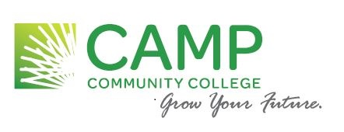
Dual Enrollment
Parental Consent Form

Both the student and a parent or guardian must sign this form!
Consent to administer placement testing and to allow possible enrollment in college courses at Paul D. Camp Community College for the following student:

Last Name: __________________________ First Name: _________________________ MI: _____
High School: ____________________________________ Expected HS Graduation Year: _________
Date of Birth: __________________ Age: ____ College (SIS) ID#: _________________________

As a dual enrollment student, I understand that dual enrollment courses are college courses offered through Paul D. Camp Community College. I am fully aware that the grade(s) I earn in these classes will be part of my permanent college record and could therefore affect my college standing and eligibility for future financial aid or guaranteed admissions agreements.
Signature of Student: ____________________________________ Date: _____________________
As a parent/guardian of the above student, I agree to allow placement testing and enrollment into dual enrollment courses with PDCCC. I understand these classes are located at either the high school, online or at a designated campus or site. Additionally, I understand that dual enrollment classes are college level courses and final grades will be part of my child’s permanent college record. I further certify that I and the above student have completed the domicile form included with the application for admission, to determine in-state residency.
The signature of a parent or guardian is required for all students under the age of 18:

________________________________________________ Date: ___________________________
Signature of Parent or Guardian

Judith Wachsmann
PDCCC Dual Enrollment Coordinator jwachsmann@pdc.edu
(757) 569-6081

FERPA Waiver
The Family Educational Rights and Privacy Act (FERPA) specifies the rights of the students to privacy and confidentiality with respect to their education records. Completion of this form by the student grants permission to college officials to disclose and discuss the student’s education records with persons specified below. The student’s signature below confirms their agreement to this disclosure.
This form must be signed by the student ONLY. It will not be valid unless signed by the STUDENT.

Student Name: ________________________________
College (SIS) ID#: ________________________________
High School: ________________________________

I agree to allow the following person(s) access to information about my progress in dual enrollment courses, including but not limited to grades, attendance, schedule, and payment balances.
(1) Name:______________________________________________ Relationship: ____________
Address: _____________________________ City: _____________ State: _____ Zip: _________

(2) Name:_______________________________________________ Relationship: ___________
Address: _____________________________ City: _____________ State: _____ Zip: _________

(3) Guidance Counselor’s Name: __________________________________________________

Student Signature: ______________________________________ Date: ________________

